|  |  |  |  |  |  |  |  |  |
| --- | --- | --- | --- | --- | --- | --- | --- | --- |
|  | | | | | | | | |
|  | | Expense Tracker | | | | |  | |
|  |  | | | | | | |  |
|  | | | |  |  | | | |
|  | | | | Tomas Nguyen |  | | | |
|  | | | | 21.01.2021Computer Science 2Matriculation number: 47307 |  | | | |
|  | | |  | | |  | | |

|  |  |  |  |  |  |  |  |  |
| --- | --- | --- | --- | --- | --- | --- | --- | --- |
|  |  | | |  |  | | |  |
|  | Introduction | | | | | | |  |
|  |  | | |  |  | | |  |
|  |  | |  | | |  | |  |
|  |  |  | The purpose of the expense tracker is to keep track of expense data of myself. It will show, how much money do I spend each month in 2020 and what did I spend money on.  The expense tracker will be able to search for certain expense’s category.  Every month I set the limit for my monthly expenditure and the program will check the data if the expense is within the limit or not. | | |  |  |  |
|  | | | | |
|  |  |  |  |
|  |  |



|  |  |  |  |  |  |  |  |  |  |  |  |  |
| --- | --- | --- | --- | --- | --- | --- | --- | --- | --- | --- | --- | --- |
|  | | | |  | |  | |  | |  | | |
|  | | | | UML | | | | | |  | | |
|  | | | |  | |  | |  | |  | | |
|  | | * My UML consists of 2 classes. The Expenditure has attributes of monthly expenses, it has also one constructor to construct Expenditure each month. * Due to the privacy of the class member’s variable, I had to create a getters to get the data. * Second class is the manager which will provide the information to the Expenditure class. It has one vector to store the data from file. I create a view functions to display the data of each category, also it has more uses, which I will provide further details with codes. | | | | | | | | | |  |
|  | | | |  | |  | |  | |  | |
|  | |

**Implementation**

**Expenditure class**

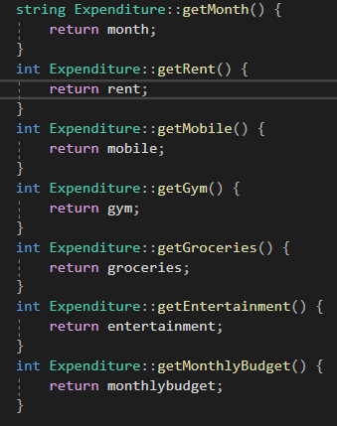 Here are getters in Expenditure class to get the data from private attributes.

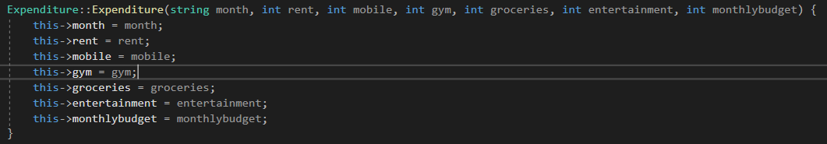

Constructor here plays big role in ExpenditureManager class to store the data.

**ExpenditureManager Class**

Here is the code which I used to get data from a file and store it into the vector.

By using stringstream I was able to separate the data and put it into the vectors expense and time. At the of while loop I put a data inside constructor with different elements of vector. With the function Database.pushback(Tom) I store the data into vector Database;

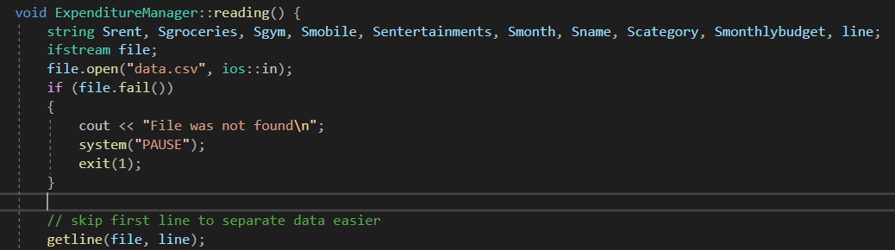

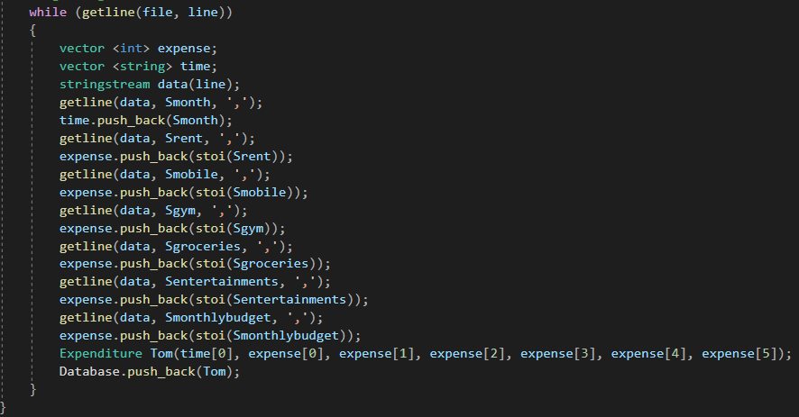

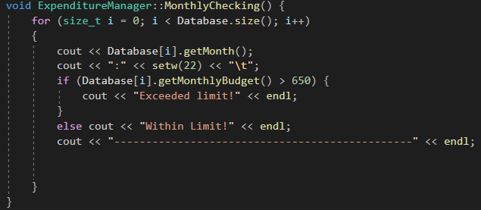

One of function to check if the monthly budget falls within limit or not.

Here I used the setw() function to make displaying on console looks better.

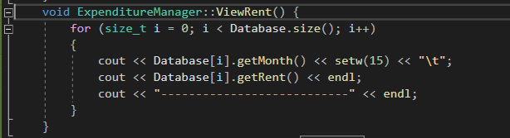To display the stored values in Databse vector. I create a function to show each value. Here is how I display a rent each month.

**Conclusion**

* My main goal was to gain the basic knowledge about object-oriented analysis, design, and implementation using the Unified Modeling Language, which was achieved after finishing my project.
* Second aim was to study about object-oriented programming to implement real-world entities like inheritance, hiding, polymorphism, etc in programming.
* Everything in this project was created by the knowledge from the lectures. Only thing issue I have came across during working with my project was file handling, getting data and store them to able to use.